**CREATING IBM CLOUD SERVICE**

|  |  |
| --- | --- |
| **TEAM ID** | PNT2022TMID29999 |
| **PROJECT NAME** | GAS LEAKAGE MONITORING AND ALERTING SYSTEM FOR INDUSTRIES |

**STEP 1:**

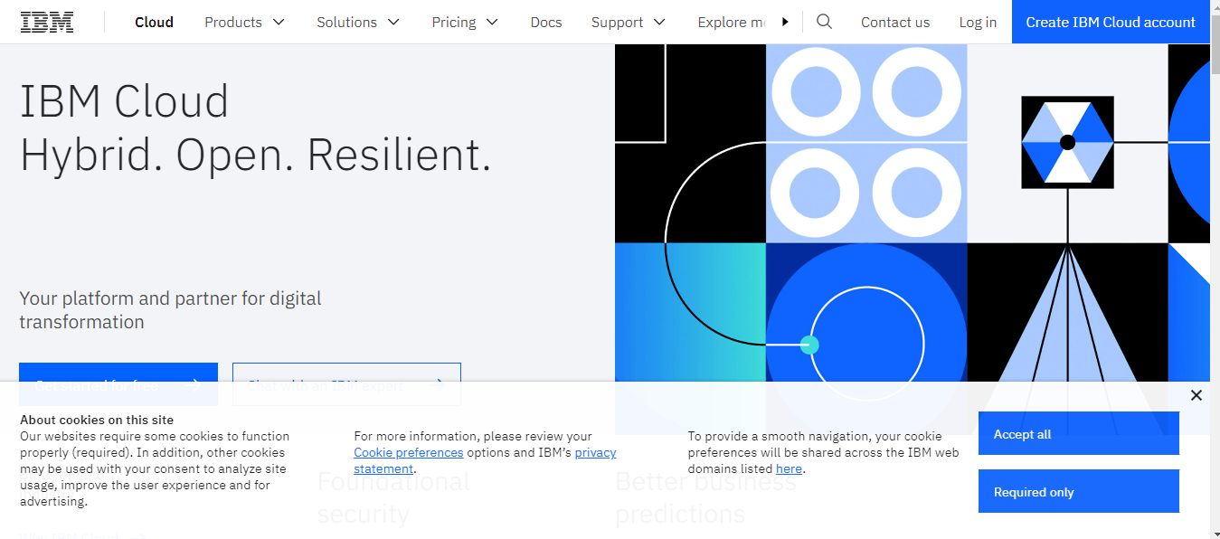

**STEP 2:**

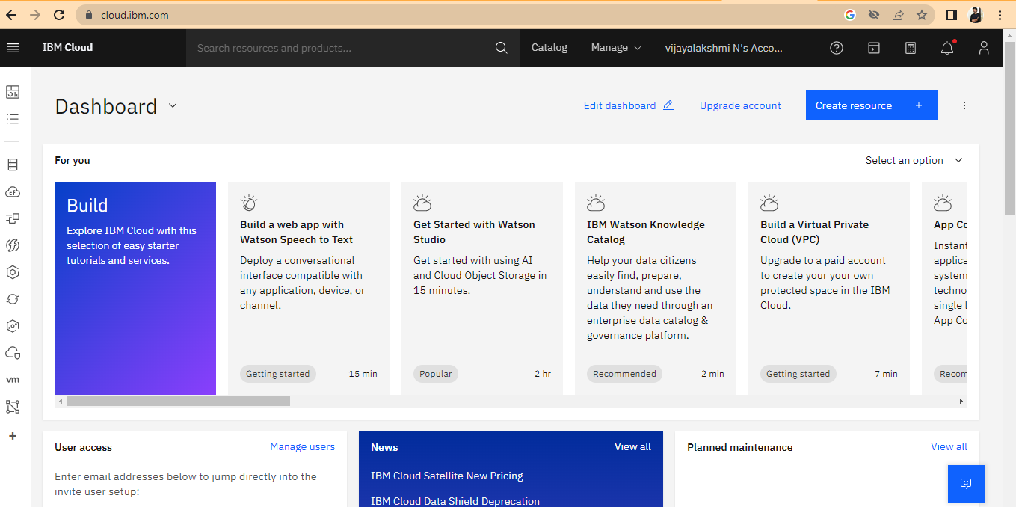

**STEP 3:**

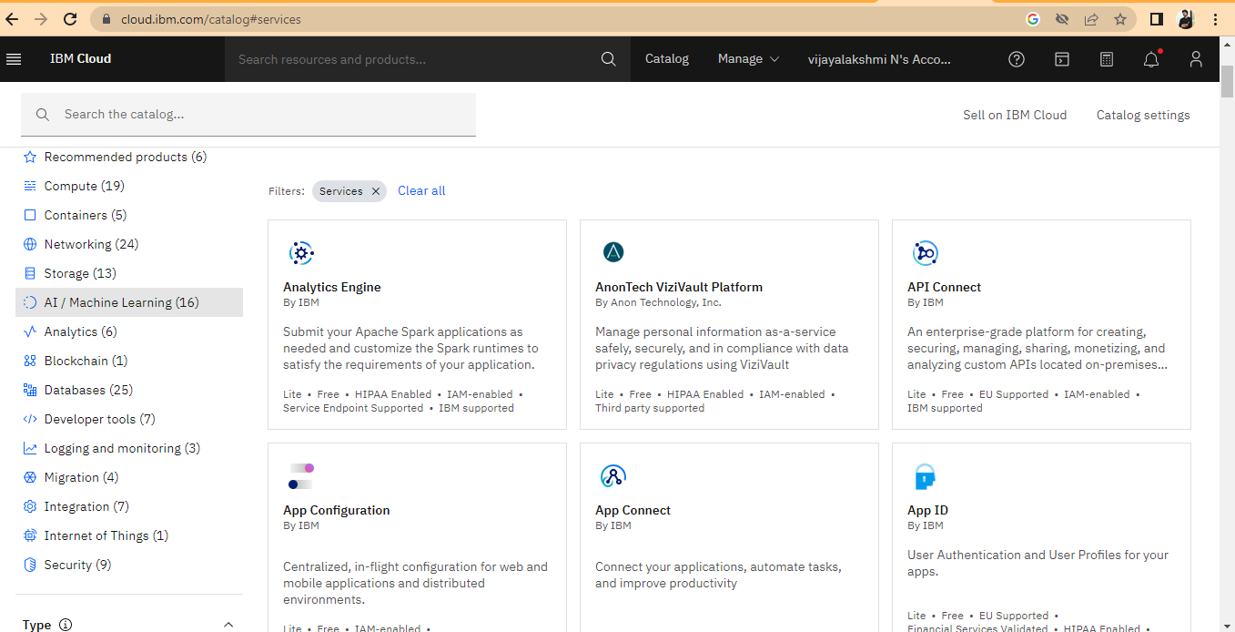

An IBM Cloud services created successfully .